

Business Interoperability Specification


OpenPEPPOL AISBL

Post Award Coordinating Community

BIS common text and introduction

Version: 1.00
Status: In use

Statement of copyright

This OpenPEPPOL BIS specification is released by OpenPEPPOL (www.peppol.eu) under the terms of the Creative Commons BY-NC-ND license accessed through the following link: http://creativecommons.org/licenses.
In short, this license allows others to download and share the work of OpenPEPPOL as long as they credit OpenPEPPOL. It is not allowed for others to change the work of OpenPEPPOL in any way or use them commercially, unless explicitly authorized by OpenPEPPOL to do so.

This OpenPEPPOL BIS specification is based on, and re-use part of, work published by CEN/WS BII (www.cenbii.eu), for which CEN (www.cen.eu) holds the copyright, and OASIS TC/UBL (https://www.oasis-open.org/committees/tc_home.php?wg_abbrev=ubl), for which OASIS (https://www.oasis-open.org/) holds the copyright.

Table of Contents
1 References 4
2 Document history 5
2.1 Revision history 5
2.2 Contributors 5
3 Introduction 5
3.1 BIS and CEN BII 5
3.2 Target group 6
3.3 The PEPPOL BIS – short overview 7
3.4 PEPPOL BIS in relation to the PEPPOL infrastructure 7
3.5 PEPPOL Interoperability, conformance and testing 8
3.6 PEPPOL Implementation support 9
3.7 Published PEPPOL BIS 9
3.8 How to read the detailed schema guide sections of a PEPPOL BIS 9
3.8.1 The use of empty elements is banned in UBL 9
3.8.2 Cardinality and Rules in PEPPOL BIS 9
3.8.3 General interpretation regarding heading "Description"/"Use" and specific rules in the schema guide 9

References

[PEPPOL] http://www.peppol.eu/
[PEPPOL_EIA] http://www.peppol.eu/peppol_components/peppol-eia/eia
[PEPPOL_PostAward] http://www.peppol.eu/peppol_components/peppol-eia/eia#ict-architecture/post-award- eprocurement/models
[PEPPOL_Transp] http://www.peppol.eu/peppol_components/peppol-eia/eia#ict-architecture/transport- infrastructure/models

[CEN_BII] www.cen.eu/cwa/bii/specs
[CEN_BII2] http://www.cenbii.eu
[BII_Invoice] ftp://ftp.cen.eu/public/CWAs/BII2/CWA16562/CWA16562-Annex-B-BII-Profile-04-InvoiceOnly-V2_0_0.pdf
[BII_InvoiceModel] A browsable HTML version:
http://spec.cenbii.eu/BII2/fxhtml/Trdm010-Invoice/g_1.htm?http://spec.cenbii.eu/BII2/fxhtml/Trdm010-Invoice/g_5.htm

[UBL] http://docs.oasis-open.org/ubl/prd3-UBL-2.1/UBL-2.1.html
[UBL_Invoice] http://docs.oasis-open.org/ubl/prd3-UBL-2.1/xsd/maindoc/UBL-Invoice-2.1.xsd
[Schematron] http://www.schematron.com
[XSLT] http://www.w3.org/TR/xslt20/

[DIR_2006/112/EC] Council Directive 2006/112/EC of 28 November 2006 on the common system of value added tax, found at:
http://eur-lex.europa.eu/LexUriServ/LexUriServ.do?uri=CELEX:32006L0112:EN:NOT

[DIR_1999/93/EC] Directive 1999/93/EC of the European Parliament and of the Council of 13 December 1999 on a Community framework for electronic signatures, found at:
http://eur-lex.europa.eu/LexUriServ/LexUriServ.do?uri=CELEX:31999L0093:EN:NOT

[EIF] European Interoperability Framework 2.0, found at: http://ec.europa.eu/isa/library/index_en.htm http://ec.europa.eu/isa/documents/isa_annex_ii_eif_en.pdf

[GS1 Keys] http://www.gs1.org/barcodes/technical/id_keys

Document history

Revision history

Version | Date | Author | Organization | Description
1.0 | 14.04.2014 | Anders Kingstedt | ESV | First version

Contributors
Jostein Frømyr, Difi/Edisys Consulting AS, NO
Martin Forsberg, SFTI, SE
Sven Rostgaard Rasmussen, DIGST, DK
Sören Lennartsson, SFTI, SE

Introduction
The PEPPOL Business Interoperablity Specification, “BIS” from here on after, has been developed by the OpenPEPPOL AISBL Post Award Coordinating Community and is published as part of the PEPPOL specifications.

The BIS provides a set of specifications for implementing a specific PEPPOL business process. The requirements of the business process are primarily those who form the basis for ensuring interoperability in the domain “pan-European Public e-Procurement”.

The BIS provides guidelines on how to support the process specific requirements and how to implement these.

A BIS is based on a CEN WS/BII Profile.

The purpose of this document is to provide a common introduction to and description of the BIS documents. This document is referenced from the introduction section of each individual BIS.

BIS and CEN BII
The relationship between BIS and CEN BII is illustrated below.

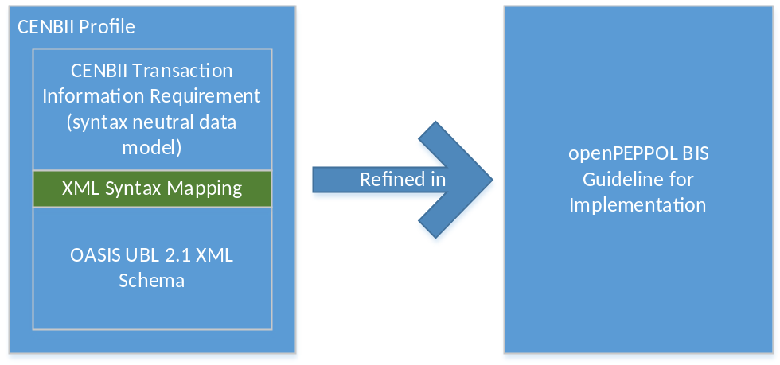
Figure – the relationship between CEN BII and PEPPOL BIS

The basis for any BIS is the CEN BII specifications, manifested in a profile. The BIS might correspond to the underlying BII specification without any restrictions, or it might contain restrictions and/or extensions made to the BII specifications. An accompanying conformance statement is used to document the details of how a BIS relates to the corresponding CEN BII profile.

BIS Customization of BII specifications
CEN BII provides two important elements that denote:
  - The process / profile (ProfileID)
  - The business transaction / customization (CustomizationID)

This XML snippet shows a BII profile without any customization:

This XML snippet shows the same BII profile with a customization:

This element identifies the customization (in this case BIS 4a issued by OpenPEPPOL).

For more information on the Customization feature of BIS, please refer to the “Guidelines for Conformance and Customization”.

Target group
The target group for this document is organizations looking to PEPPOL as the basis for interoperable solutions that enable the exchange of e-Procurement domain information.

Target organizations may be:

Service & Systems providers
Contracting Authorities
Economic Operators
Software Developers

The specifications are typically useful for these roles (not excluding other potential user categories):
ICT Architects
ICT Developers
Business Experts

The PEPPOL BIS – short overview
Background
During the development of PEPPOL it became necessary to correct and elaborate specifications related to some entities, simply because the underlying specifications that formed the basis for PEPPOL’s various software elements lacked sufficient coverage. In addition to extending the specification, the PEPPOL project also developed detailed guidelines and implementation instructions to further assist implementers of PEPPOL elements.
These implementation guides are called PEPPOL BIS (“Business Interoperability Specification”).
The PEPPOL BIS provides a set of specifications that enable communication of e-Procurement information through the PEPPOL network. The specifications enable any organization to exchange information electronically ensuring that legal and business processing requirements within the European Union and the EEA are covered. BIS supports common and typical business processes used by most industries. It enables users to issue business messages (such as invoice, orders) designed to work in a cross border setting.
The BIS defines a set of information elements (business terms) and business rules to ensure that requirements are fulfilled and to clarify any option that would otherwise be left open to implementers to decide on.
BIS also provides policies that describe and explain the use of identifiers (party, address and various codes).
The scope of BIS
The BIS does not support data that is specific to certain industries or data that might be required in other domains outside the e-Procurement domain.
Trading partners can bi-laterally or within a trading context, provide additional content and rules to meet their specific needs using a BIS as the baseline for further customizations. This would require the designation of a new unique CustomizationID in order to separate it from the regular CEN BII or BIS transaction.

PEPPOL BIS in relation to the PEPPOL infrastructure
The BIS can serve as a standardized communication agreement within a trading community – a “contract” - and can be reused for new trading partners without any additional setup cost. Implementing BIS subsequently offers the ability to exchange documents with various trading partners without previous bi-lateral setup (which in turn substantially reduces the cost of administrating electronic trading partners).
The PEPPOL approach is to promote the BIS as a procurement community agreement. One of the defining features of PEPPOL is the service registries function (known as “SMP”) where trading partners register their capabilities in terms of receiving electronic documents according to a specific BIS (one or more). This registration constitutes a community agreement: any PEPPOL partner can look up these capabilities and engage in a document exchange with the registered company without previous agreement or bi-lateral setup.
A BIS can be seen as part of a standardized communication agreement that deals with:
- the sequence of information exchange in a given process / work flow (known as “choreography”)
- the content of information elements / business documents (data elements)
- the business rules that govern the exchange of information
The PEPPOL specifications for the Post Award provide support for the steps in the procurement process following from a signed contract, linking information flow from catalogues, through ordering into billing. For further information, please refer to the PEPPOL web site (www.peppol.eu) and the Post Award section.

PEPPOL Interoperability, conformance and testing
PEPPOL actors must adhere to the specified conformance rules in order to use PEPPOL for information exchange. The conformance requirements implies that:
- issuing systems/services must issue documents that do not violate the BIS rule set,
- receiving systems/services must be able to process/understand all content of the BIS for which they are registered in the SMP.
Conformance is therefore expressed as a requirement on the software solution implementing the BIS and measured against document instances. Participants in the PEPPOL network register capabilities to receive documents, while issuers of documents do not register capabilities but commit themselves to be conformant to BIS.
Conformance is measured against a specific BIS and is measured against three key aspects:
- Choreography; compliance is measured against the sequence of collaborations and transactions defined in the BIS. Any software solution claiming compliance to a profile is expected to be able to support all business collaborations and business transactions defined in the BIS.
- Data content; compliance is measured against the transaction data model in the BIS. Any software solution claiming conformance to a BIS is expected to be able to process and understand all elements defined as part of the relevant transaction data models referenced by the BIS. This requirement implies that the receiving applications must be able to process/understand all content, while issuing applications must issue documents that do not violate the BIS rule set.
- Business rules; conformance is measured against the rules stated at collaboration and transaction level of the BIS. Any software solution claiming conformance to a BIS is expected to adhere to all business rules stated within the BIS description and the referenced transaction data model.

PEPPOL Implementation support
The PEPPOL BIS are bound to the UBL syntax. OpenPEPPOL provides a set of tools and specifications for implementation support.
These may include:
- Business rules and code lists.
- Schematron components for validation of the business rules that apply to the content.
- Stylesheets for presentation.
- An HTML presentation of the data model for browsing.
- Example documents and test cases
Detailed information of the above elements is provided in the PEPPOL BIS document.
In addition to the implementation support provided in the respective BIS documents, several validation tools are also available, accessible from the Internet. These validation tools are provided from independent service providers.

Published PEPPOL BIS
The latest versions of the BIS are made available at the PEPPOL.EU site (www.peppol.eu), see “PEPPOL Elements”.

How to read the detailed schema guide sections of a PEPPOL BIS

The use of empty elements is banned in UBL
As explained in section 1.1, the PEPPOL BIS schema guide builds on OASIS UBL 2.1. As a consequence the UBL rules on empty elements are inherited, as follows:
”[IND5] UBL conformant instance documents MUST NOT contain an element devoid of content or containing null values, except in the case of extension, where the UBLExtensionContent element is used.

To ensure that no attempt is made to circumvent rule IND5, UBL also prohibits attempting to convey meaning by not conveying an element.

[IND6] The absence of a construct or data in a UBL instance document MUST NOT carry meaning.”

Cardinality and Rules in PEPPOL BIS
In PEPPOL BIS schema guides, cardinality represents a necessary but not a sufficient condition for compliance - the requirements of any associated rules have to be observed as well.

Example from the schema guide in BIS 5A: InvoicePeriod includes the elements StartDate and EndDate. They have cardinality 0..1 but due to rules BII2-T14-R023 and BII2-T14-R024 both elements have to be present in a compliant instance of Credit Note.

General interpretation regarding heading "Description"/"Use" and specific rules in the schema guide
In PEPPOL BIS schema guides, "Description"/"Use" marked as Optional is overridden by the requirements of any associated rules.

Example from the schema guide in BIS 5A: cac:CreditNoteLine/cbc:CreditedQuantity has attributes unitCode and unitCodeListID defined as Optional but the rules BII2-T14-R019, OP-T14-R006 and EUGEN-T14-R030 require presence of both attributes and with specified set of values in order for an instance of the Credit Note to comply.

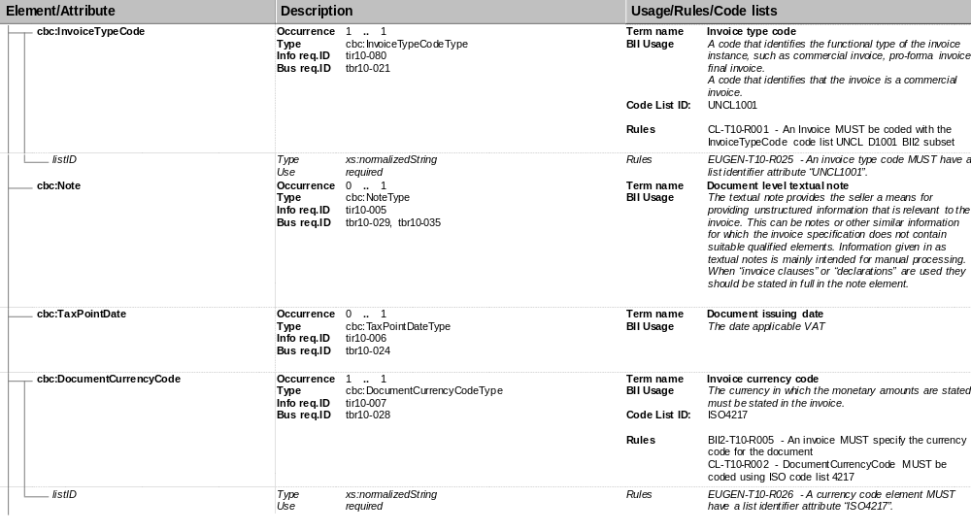
1
2
3
4
5
6

Legend:

1 | Tree view of elements and attributes. Elements are prefixed with a default namespace prefix but an actual instance file may use other prefixes as long as the namespace declarations are correct.
2 | Element name or Attribute name
3 | Occurrence – the cardinality of the element.  Type – the type defined in the UBL XML Schema for this element.  Info Req.ID – a unique identifier for the defined information requirement.  Bus Req.ID – a unique identifier for a high level business requirement that can be fulfilled by the use of this (and other) elements.
4 | Term Name – A common name of the business term  BII Usage – A description of the meaning of usage of this business term.
5 | Code List ID – A reference to a code list constraining the allowed values for this element/attribute.  Rules – An identifier and textual description of a business rules governing the use of this element/attribute (and sometimes dependencies with other elements).
6 | Type – the type defined in the UBL XML Schema for this element.  Use – Optional or required attribute. Represents a necessary but not a sufficient condition for compliance - the requirements of any associated rules have to be observed, as well.

The word ”Public” implies that the e-Procurement always involves a Contracting Authority in the Public domain. Even though the original PEPPOL Large Scale Pilot was initiated on the premise to provide support for public authorities and even though the public sector is still an important and relevant stakeholder of PEPPOL, it should be noted that any traffic going through the PEPPOL network might be on a ”business-to-business” basis only.
EEA is short for the “European Economic Area”. Current members are Iceland, Liechtenstein and Norway.
Although this document refers to e-Procurement in the Post Award domain specifically, the purpose, structure and general set-up is also applicable for the Pre Award domain.

